CHAPTER 1 : INTRODUCTION

In the fast changing world, information technology and information management are going to play an important role. We are living in the computer age during past some year. The computer has gaining popularity. Computer revolution found its way into almost every aspect of human life and living. A computer is admirably suited to handle any information and hence is an information processor that is, it can receive data, perform some basic operations on that data and produces results according to a predetermined program.
Online Skill Matrix System is a project in which online Skill Matrix facility is provided to the students through that they can check their knowledge level and programming skills.
This project is basically divided into three modules. First module is Admin Module which controls all the process whereas Member Module actually uses the software associated with the website and the last Registration Module which Concern with all the process regarding registration.

1.1 Background
In the background of online Skill Matrixination system a lot of paper work was done and a lot of human resource was needed to conduct any type of Skill Matrixination. By using this system all the paper and manual work can be removed and things would become much simpler. This is a new approach to test the skills of students in shorter span of time. There is no need to perform manual checking of answers of questions within minute results can be generated. There is no bound on conducting Skill Matrixination. It could be conducted either in the morning or late night. Users also would have facility to give Skill Matrixs by sitting any part of the work.
    - System Objective
Today’s world is computer world because most of work is doing with the help of computer. Dependency on computer is behind the few reasons. We cannot easily manage to store large number of data or information single handle. If we will be need some information or data in urgency then we cannot manage in manually these works are very difficult if we cannot use computer.

1.1.2 System Context:
This section clearly depicts the environment and boundaries of the OES and the entities with which it interacts. it helps us see how the system fits into the existing scheme of things. What the system will do by itself and what it expects other entities to do is clearly delineated.

1.1.3 Functional Requirement:

The functional requirement of project is that records of all students who have appeared for Skill Matrixs should be kept safely and whole session of Skill Matrixination conduction should be carried on smoothly.

1.1.4 Non-Functional Requirement
These are quality requirement that stipulate the performance levels required of the system for various kind of activate. Numerical lower and upper limits set conditions on the response times, access times etc of the system. Sometimes tradeoffs a re necessary among various non-functional requirements.

    - Future Requirement

These are the specifications which are not provided for now in the current version of OES but which could be incorporated into future versions. Some of these need advanced technologies and interface with other system. The OES could be designed in future to enhance the existing capabilities or add entirely new ones.

1.2 OBJECTIVES
So the objective of this project is to overcome the limitation of the manual approach. This project is started towards systematically automating all the work that is done manually at present. Their aim is to focus following aspects:
- The main objective is to automate non computer environment
- To save manpower.
- It will speed the processing of data and transaction.
- It will provide all the error reporting and handling features, so that the user is warned and made aware of any foreseen errors. Thus it will reduce the error rate.
- It will provide various ways through which we generate various types of report.
- It will provide best security features such as provisions of passwords.

1.3 Problem Defination
The main problem with conventional Skill Matrix was a lot of paper work and a lot of human resource was needed to conduct any type of Skill Matrix. By using this system all the paper and manual work can be removed and things would become much more simpler. This is a new approach to test the skills of students in shorter span of time. There is no need to perform manual checking of answers of questions within minute results can be generated. There is no bound on conducting Skill Matrix. It could be conducted either in the morning or late night. Users also would have facility to give Skill Matrix by sitting any part of the work.

  - Purpose
The purpose of the project is quite simpler. It would facilitate the students to give Skill Matrix by sitting on their PC’s using the web technology and giving the Skill Matrix. Just on a single click answer would be submitted and their is no need of a lot of papers which was used previously.
  - Scope
The scope of the project is very vast. It can be further enhanced in which all India level Skill Matrix would be conducted. If the project is further enhanced and newer technologies, concepts and security measures would be implemented.

CHAPTER 2 : Problem Formulation
Introduction
Problem introduction or problem starting is the starting point of the software development activity. The objective of this statement is to answer: Exactly what must the system do? The software project is initiated by the client’s need. In the beginning, these needs are on the minds of various people in the client’s organization. The analyst has to identify the requirements by talking to the people and understanding to their needs. It goes without saying that an accurate and through understanding of software requirement are essentials to the success of software development effort. All further development like system analysis. System design and coding will depends on how accurate and well understood the requirements are poorly analyzed and specified software will disappoint the user and will bring brief to the developer. No matter how well designed and well appearances are often deceiving. Chances of misinterpretation are very high, ambiguity is probable and communication gap between customer and developer is bound to bring confusions. Requirements understanding begin with a clear and concise heading stating in sentence the task to be performed. Then requirements are describe in a technical manner precise statement.

2.1 Feasibility study
All projects are feasible given unlimited resources and infinite time! Unfortunately, the development of computer based system is more likely to be plagued by a scarcity of resources and difficult delivery dates. It is both necessary and prudent to evaluate the feasibility of the project at the earliest possible time. Months or years of effort, Money loss and untold professional embarrassment can be averted I few better understand the project at its study time.
This type of study determines if an application can and should be developed. Once it has been determining that, application is feasible. After that analyst can go ahead and prepares the project specification, which finalizes project requirements. Feasibility studies are undertaken within tight time constraints.
- Technical Feasibility
- Operational Feasibility
- Economic Feasibility
- Legal Feasibility

2.1.1 Technical Feasibility:
As we know the technical feasibility is concerned with specifying equipment and software that will successfully satisfy the user requirement. The technical needs of the system may vary considerably, but might include:
- The facility to produce outputs of advertisements, shopping and mailing in a given time for ease of use.
- Response time under certain condition is minimal.
- Ability to process a certain volume of transaction at a particular speed.
- Facility to communicate data to distinct location.
In Skill Matrix the technical feasibility, configuration of the system is given more importance than the actual make of hardware. The configuration should give the complete picture about the system’s requirements- how many workstations are required, how these units are interconnected so that they could operate and communicate smoothly.

2.1.2 Operational Feasibility:
Proposed projects are beneficial only if they can be turned into information system that will meet the financial management requirements of the business/organization. This test of feasibility asks if the system will work when it developed and installed. Are there major barriers to implementation?
Some of the important questions that are useful to test the operational feasibility of a project are given below:
  - Is there sufficient support for the project from the implementation? From user? If the present system is well liked and used to the extent that persons will not be able to see reasons for change, there may be resistance.
  - Are current business methods acceptable to the user? If they are not, user may welcome a change that will bring about a more operational and useful system
  - Have the user been involved in the planning and development of the Project? If they are involved at the earliest stage of project development, the chances of resistance can be possibly reduced.
  - Will the proposed system cause harm? Will it produce poorer result in any case or area?
  - Will the performance of staff member fall down after implementation? Issue that
  - Appears to be quite minor at the early stage can grow into major problem after Implementation.

2.1.3 Economical Feasibility:
Economic analysis is the most frequently used technique for evaluating the effectiveness of the proposed system. More commonly known as cost/benefits analysis, the procedure is to determine the benefits and savings that are expected from the purposed system and compared with costs.
If benefits outweigh cost, a decision is taken to design and implement the system. Otherwise, further justification or alternative of the proposed system will have to be made if it has a chance of being approved. This is an ongoing effort that improves in accuracy at each phase of the system life cycle. The analysis part also clears the doubt of economic problems which could be possible in developing the system. As already mentioned that the company has to just pay the developed software cost and not other investment is needed at the time of implementation of the new system as the preliminary requirements already exist in the company.

2.1.4 Legal Feasibility:
In the legal feasibility is necessary to check that the software we are going to develop is legally correct which means that the ideas which we have taken for the proposed system will be legally implemented or not so , it is also an important step in feasibility study.

2.2 PROBLEM SPECIFICATION
The definition of our problem lies in manual system and a fully automated system.

2.2.1 Manual System
The system is very time consuming and lazy. This system is more prone to error and sometimes the approach to various problems is unstructured.

2.2.2 Technical System
With the advent of latest technology if we do not update our system then our business result in losses gradually with time. The technical system contains the tools of latest trend i.e. computers, printers, FAX, Internet etc the system with the technology are very fast, accurate, user friendly and reliable.

2.2.3 Need of Online Skill Matrixination System
The need for this system is that it has enabled the use of Internet and web server concept. Online Skill Matrixination would be done using browser at the client, and all the data would get save on a single server that is web server.

2.3 The Proposed System
The proposed system will to overcome the limitation of the manual approach. This project is started towards systematically automating all the work that is done manually at present. The main aim of this project is :
- To automate non computer environment
- To save manpower.
- To speed the processing of data and transaction.
- To provide all the error reporting and handling features, so that the user is warned and made aware of any foreseen errors. Thus it will reduce the error rate.
- To provide various ways through which we generate various types of report.
- To provide best security features such as provisions of passwords.

Modules used in the Project
There are mainly three modules in the project-
1. Admin
2. Member
3. Registration

1. Admin Features
a) Can view personal information about every user.
b) Can add and delete question.
c) Can add and delete news of the project.
2. Member Features
a) User can choose subjects in which he want to give Exam.
b) User can go for online Exam.
c) User can skip a question or give the answers of questions.
d) After Skill Exam is finished he can check about correct and incorrect answers .
e) After result he can share his experience.
3. Registration Features
a) New user can register.
b) After registration, he can view his profile.
c) If user has a need for changing any information, so he can perform updation in his profile.

2.4 Existing System
The Existing system comprises of a system in which details are to be manually handled this is not use friendly

CHAPTER 3
System Architecture and Design

3.1 DEFINING A SYSTEM
Collection of component, which are interconnected, and work together to realize some objective, from a system. There are three components in every system, namely input, processing and output
Processing
Input Output

3.1.1 SYSTEM DEVELOPMENT LIFE CYCLE
The Systems development life cycle (SDLC), or Software development process in systems engineering, information systems and software engineering, is a process of creating or altering information systems, and the models and methodologies that people use to develop these systems. In software engineering, the SDLC concept underpins many kinds of software development methodologies. These methodologies form the framework for planning and controlling the creation of an information system the software development process.
Broadly, following are the different activities to be considered while defining the system development life cycle for the said project:
- Problem Defination
- System Analysis
- Study of existing system
- Drawback of the existing system
- Proposed system
- System Requirment study
- Data flow analysis
- Feasibility study
- System design
- Input Design (Database & Forms)
- Updating
- Query /Report design
- Administration
- Testing
- Implementation
- Maintenance

3.1.2 SYSTEM ANALYSIS
Systems analysis is the study of sets of interacting entities, including computer systems analysis. This field is closely related to requirements analysis or operations research. It is also "an explicit formal inquiry carried out to help someone (referred to as the decision maker) identify a better course of action and make a better decision than he might otherwise have made.
System development can generally be thought of having two major components: systems analysis and systems design. In System Analysis more emphasis is given to understanding the details of an existing system or a proposed one and then deciding whether the proposed system is desirable or not and whether the existing system needs improvements. Thus, system analysis is the process of investigating a system, identifying problems, and using the information to recommend improvements to the system.
3.1.3 SYSTEM DESIGN
Systems design is the process of defining the architecture, components, modules, interfaces, and data for a system to satisfy specified requirements. One could see it as the application of systems theory to product development. There is some overlap with the disciplines of systems analysis, systems architecture and systems engineering. If the broader topic of product development "blends the perspective of marketing, design, and manufacturing into a single approach to product development," then design is the act of taking the marketing information and creating the design of the product to be manufactured. Systems design is therefore the process of defining and developing systems to satisfy specified requirements of the user. Until the 1990s systems design had a crucial and respected role in the data processing industry. In the 1990s standardization of hardware and software resulted in the ability to build modular systems. The increasing importance of software running on generic platforms has enhanced the discipline of software engineering.
Object-oriented analysis and design methods are becoming the most widely used methods for computer systems design. The UML has become the standard language in object-oriented analysis and design. It is widely used for modeling software systems and is increasingly used for high designing non-software systems and organizations

3.1.3.1 E-R Diagram
The entity-relationship model or entity-relationship diagram (ERD) is a data model or diagram for high-level descriptions of conceptual data model, and it provides a graphical notation for representing such data models in the form of entity-relationship diagrams. Such models are typically used in the first stage of information-system design; they are used, for Skill Matrixple, to describe information needs and/or the type of information that is to be stored in the database during the requirement analysis. The data modelling technique, however, can be used to describe any ontology (i.e. an overview and classifications of used terms and their relationships) for a certain universe of discourse (i.e. area of interest).
In the case of the design of an information system that is based on a database, the conceptual data model is, at a later stage (usually called logical design), mapped to a logical data model, such as the relational model; this in turn is mapped to a physical model during physical design.Note that sometimes, both of these phases are referred to as "physical design".There are a number of conventions for entity-relationship diagrams (ERDs). The classical notation is described in the remainder of this article, and mainly relates to conceptual modelling. There are a range of notations more typically employed in logical and physical database design.

E-R Diagram
Visiting time
id
date
N
Visitor
course
name
email
Register
Father’s name
gender
password
Personal info
Login
Password
dob
N
Controls
mobile
username
Skill Matrixinee
1
address
Q2
Admin
state
city
pin
Generates

Choose
username
result
Other Subject
Computer Subject
marks
N
N
Skill Matrixid
Option3
Skill Matrix Result
Subject
50
1
Question
Option4
Option1
Option2
Finish Test
Q_id
Questions
Perform Test

Data Flow Diagram
The data flow diagram shows the flow of data within any system. It is an important tool for designing phase of software engineering. Larry Constantine first developed it. It represents graphical view of flow of data. It’s also known as BUBBLE CHART. The purpose of DFD is major transformation that will become in system design symbols used in DFD:- In the DFD, four symbols are used and they are as follows.
- A square defines a source (originator) or destination of system data.

- An arrow identifies data flow-data in motion. It is 2a pipeline through which information flows.

- A circle or a “bubble “(Some people use an oval bubble) represents a process that transfers informing data flows into outgoing data flows.

- An open rectangle is a data store-data at rest, or a temporary
repository of data.

Context Level Data Flow Diagram:
This level shows the overall context of the system and its operating environment and shows the whole system as just one process. Online book store is shown as one process in the context diagram; which is also known as zero level DFD, shown below. The context diagram plays important role in understanding the system and determining the boundaries. The main process can be broken into sub-processes and system can be studied with more detail; this is where 1st level DFD comes into play.

Visitor
Users

Request
Response
Online
Skill Matrixination

Response
View

Administrator

Retrieve

Update

Context Diagram

First Level DFD:-
This level (level 1) shows all processes at the first level of numbering, data stores, external entities and the data flows between them. The purpose of this level is to show the major high-level processes of the system and their interrelation. A process model will have one, and only one, level-1 diagram. A level-1 diagram must be balanced with its parent context level diagram, i.e. there must be the same external entities and the same data flows, these can be broken down to more detail in the level 1
Sudent Information
Choose Subject Information
Student Result
Student Result
Register

Choose
Subject
Online
Skill Matrix
Update

Database
Add
Info

Subject

Subject Information

First Level DFD

Data Tables

RegistrationTable :
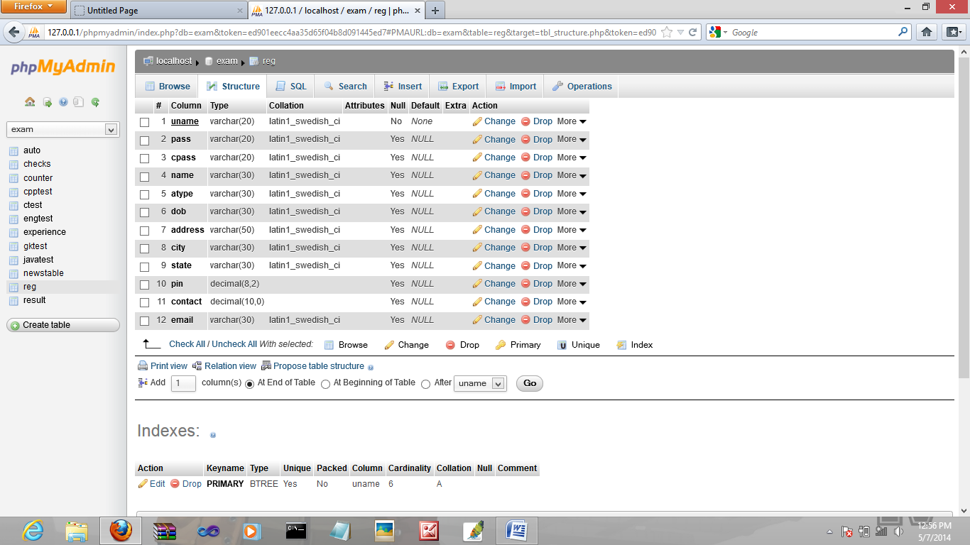
C Test Table :
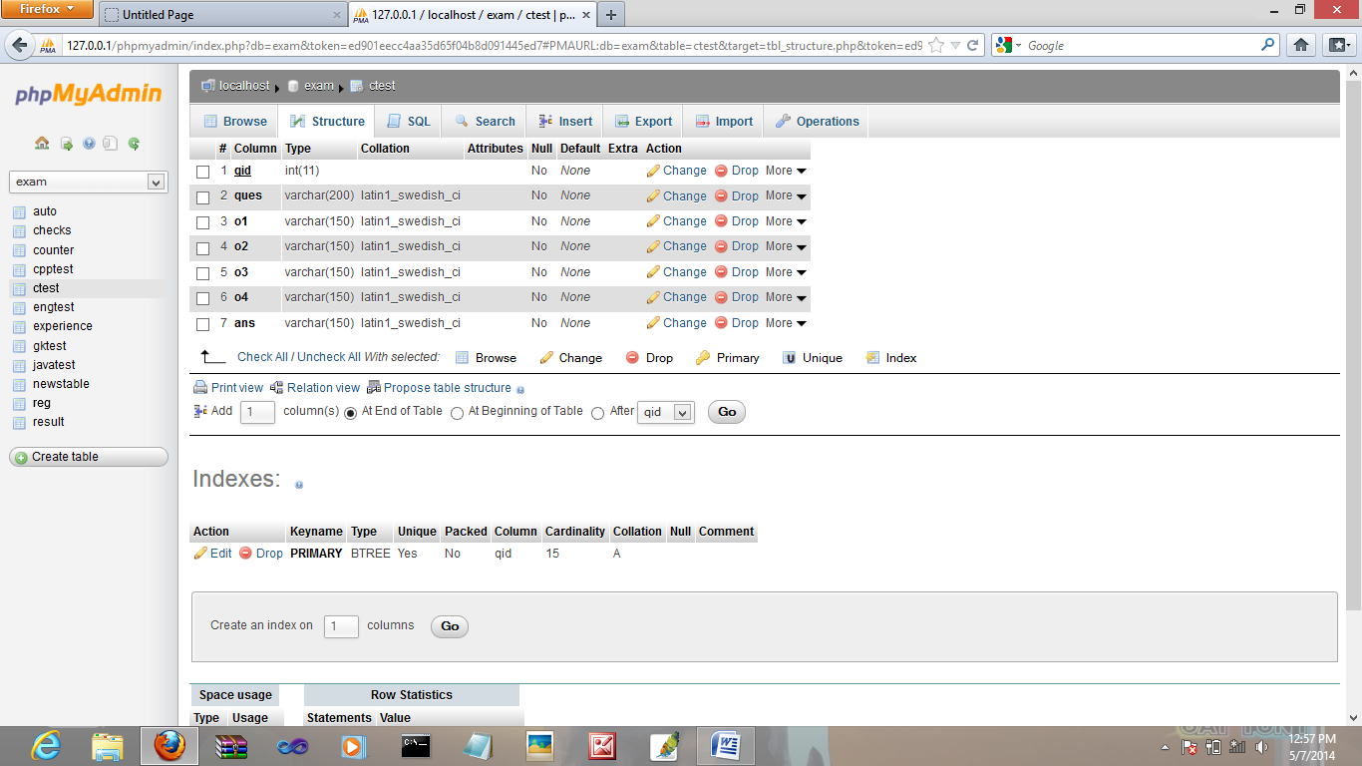
CPP Table :
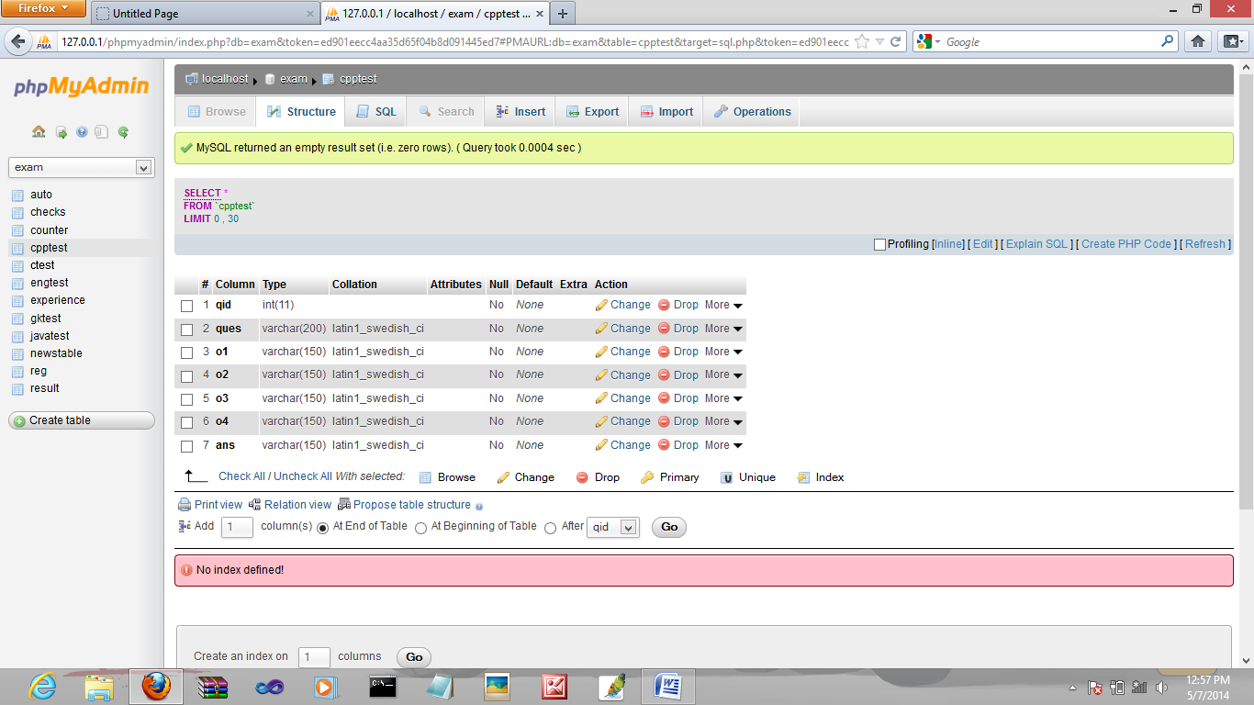
JavaTest :
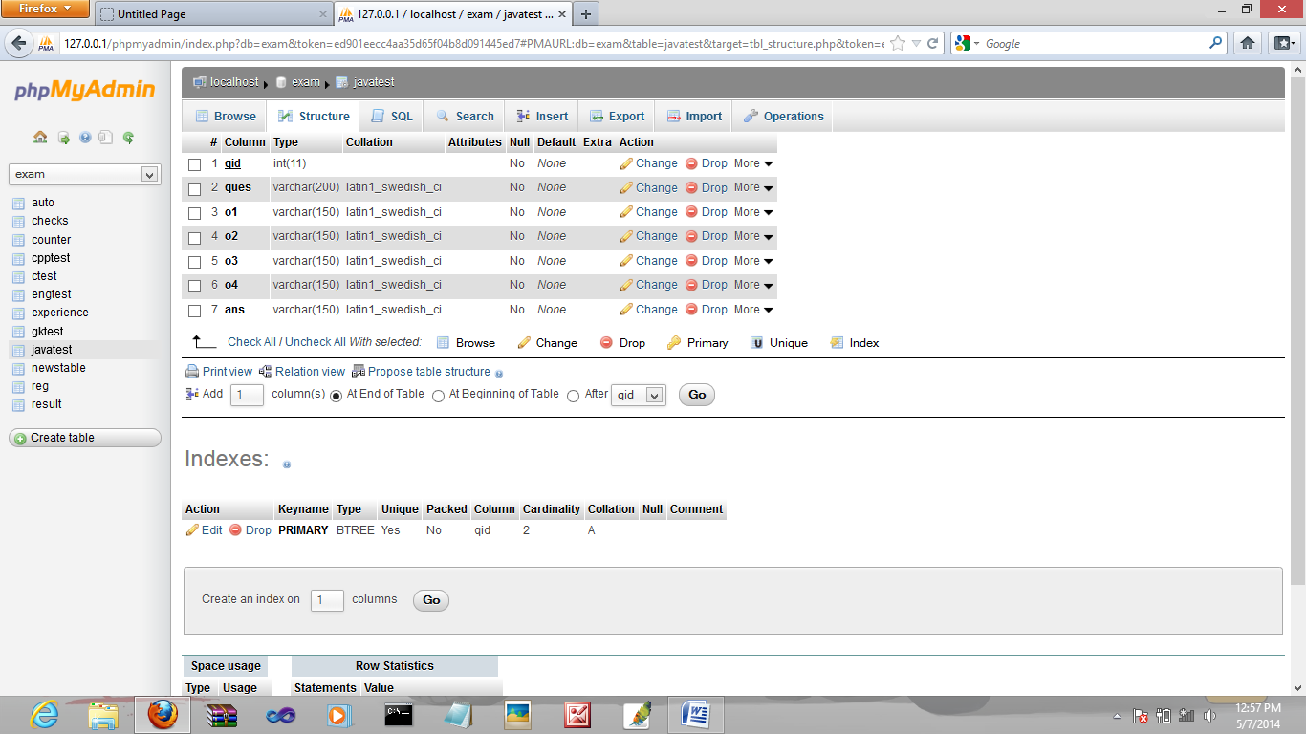
GK Test :
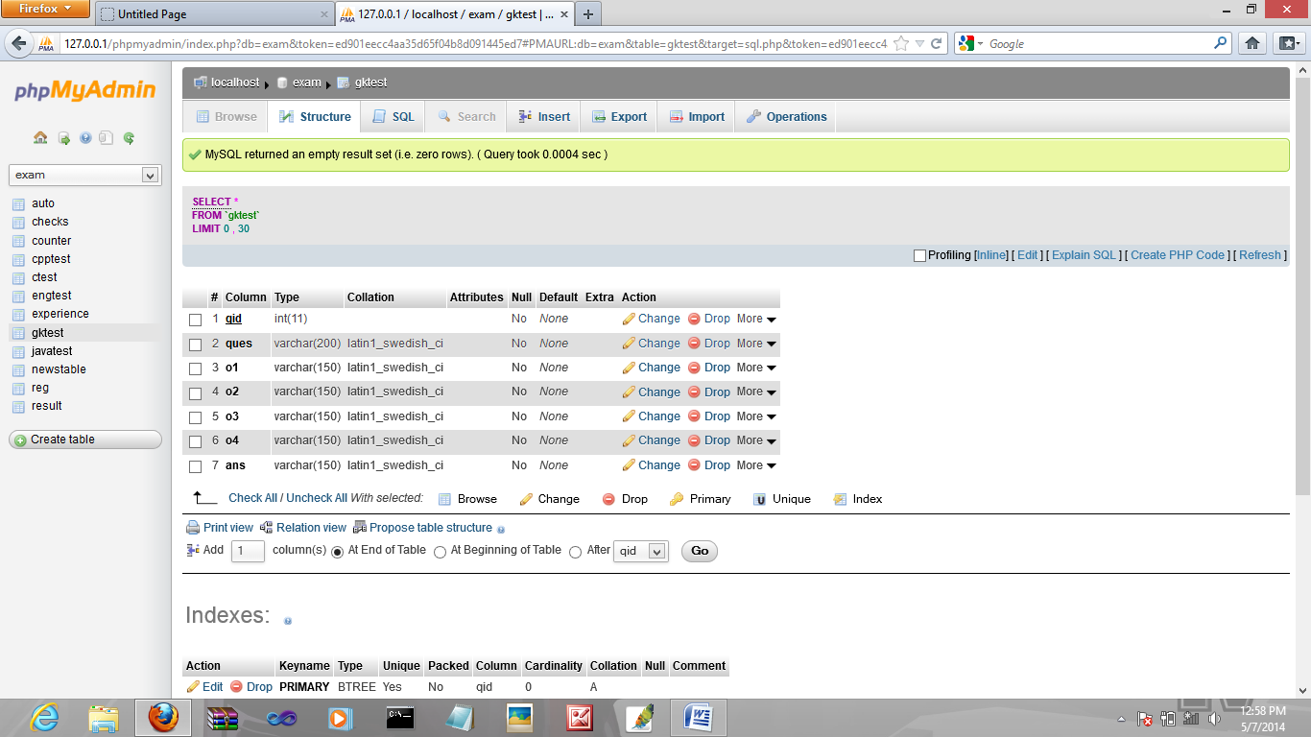
Eng Test :
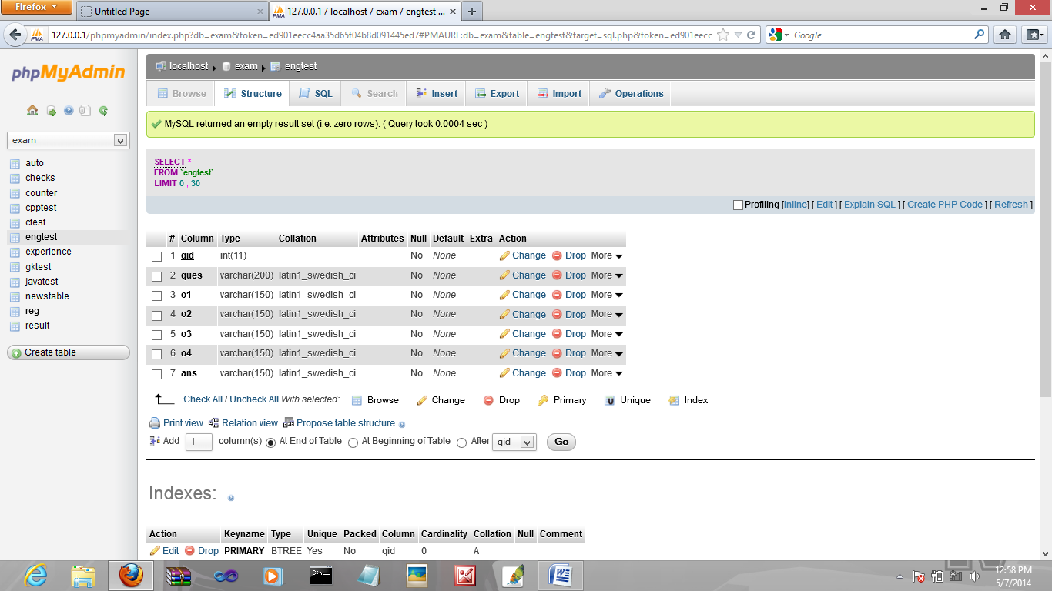
Experience :
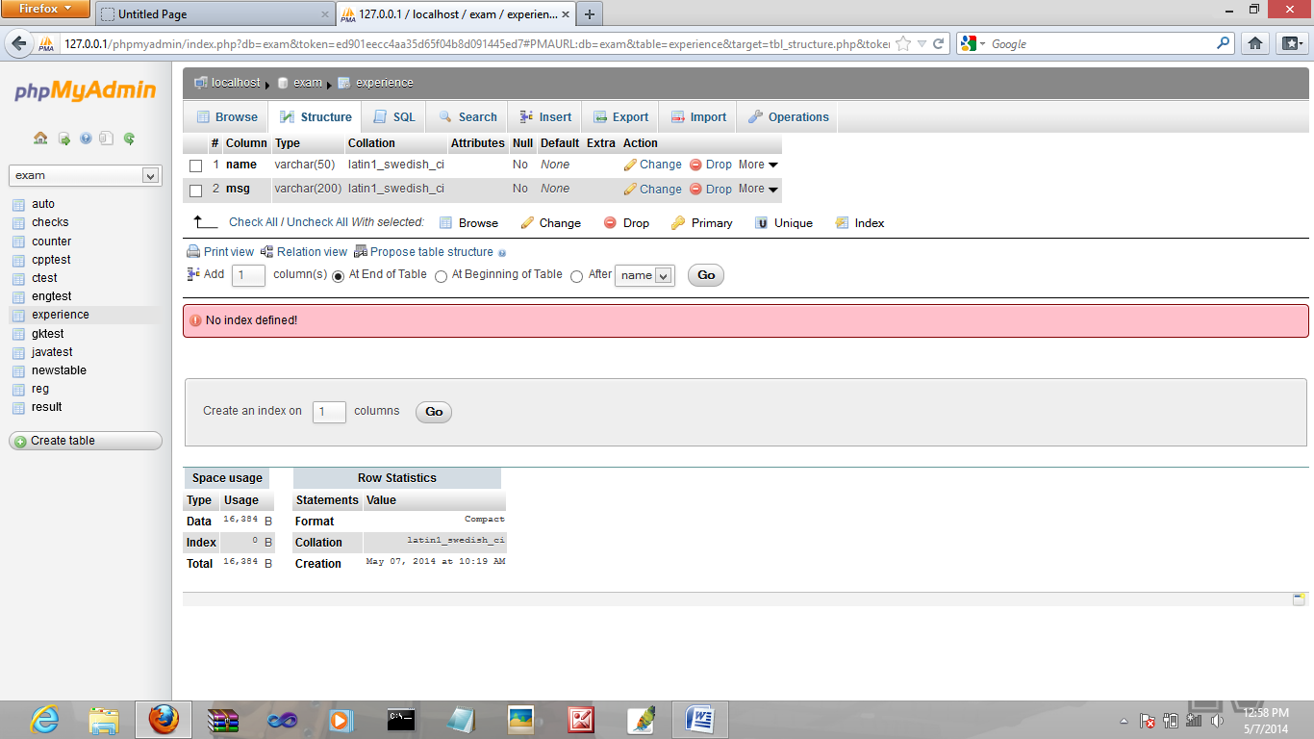
News Table :
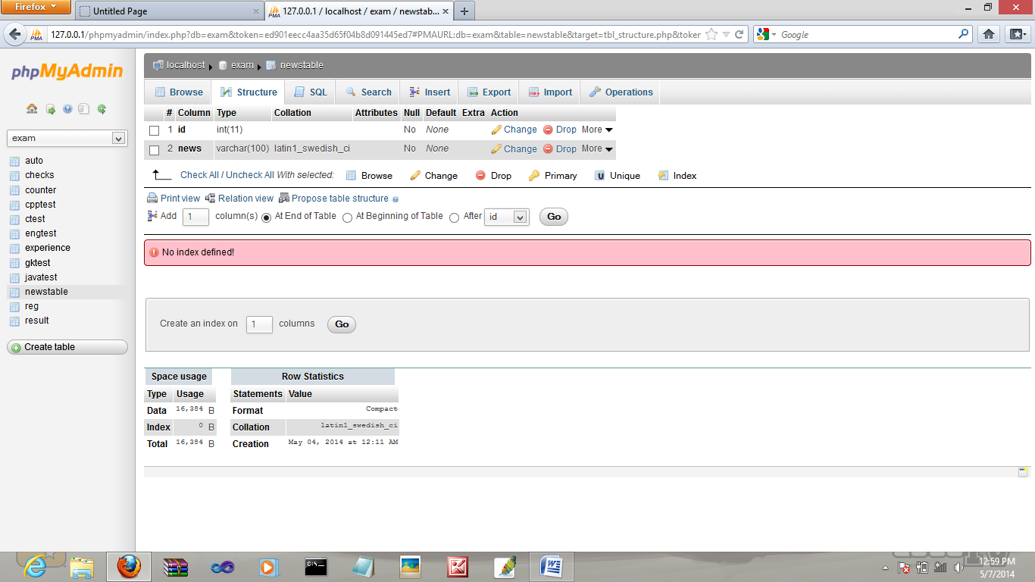
Result Table :
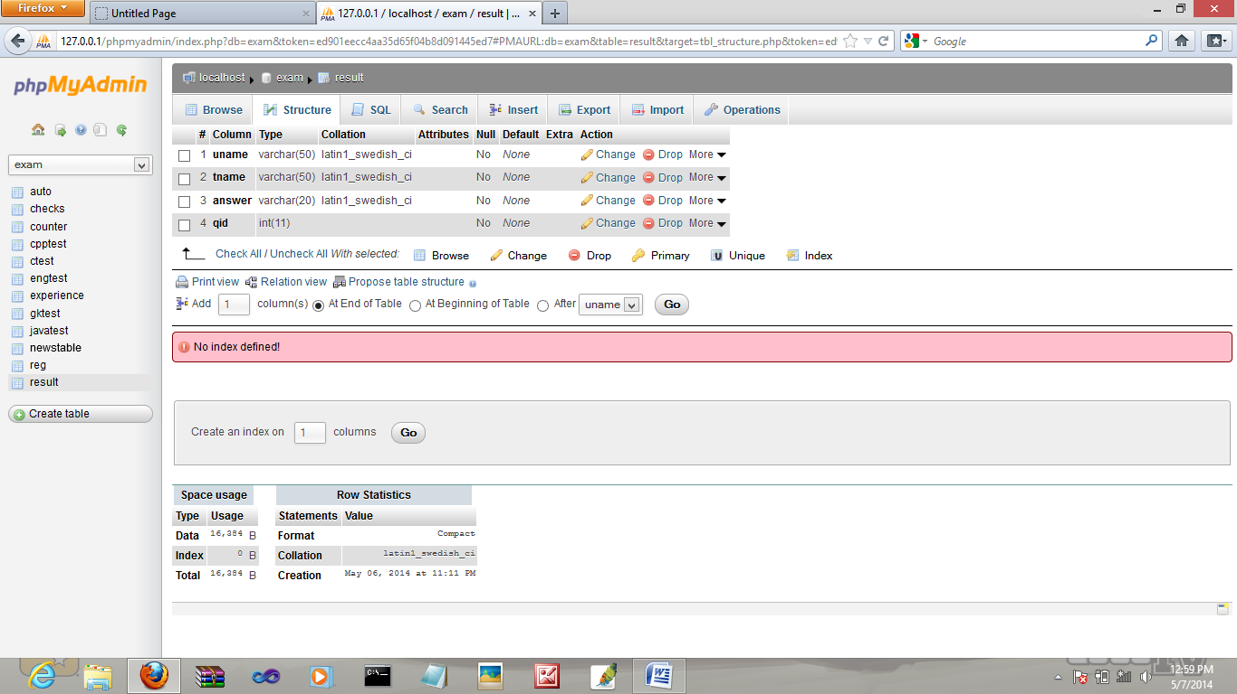
Checks Table :
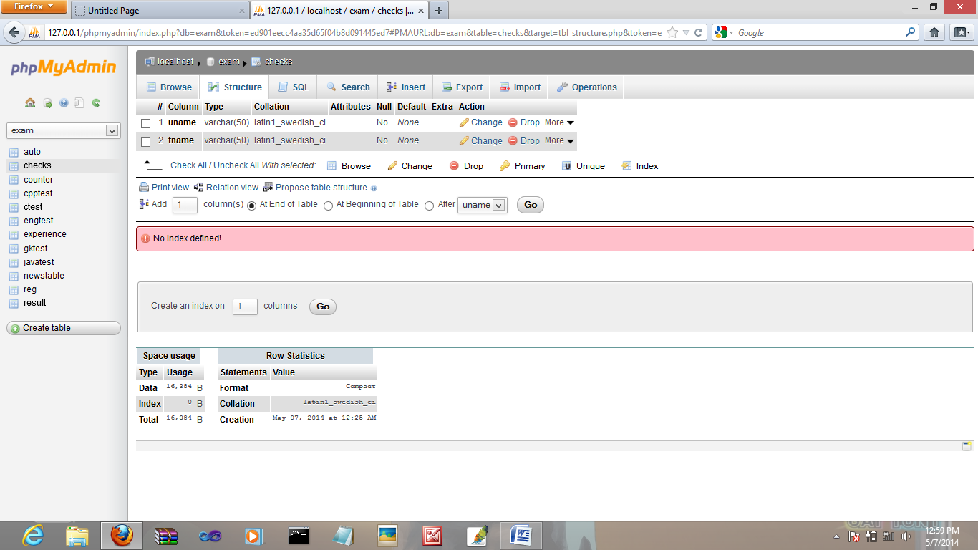
Counter :
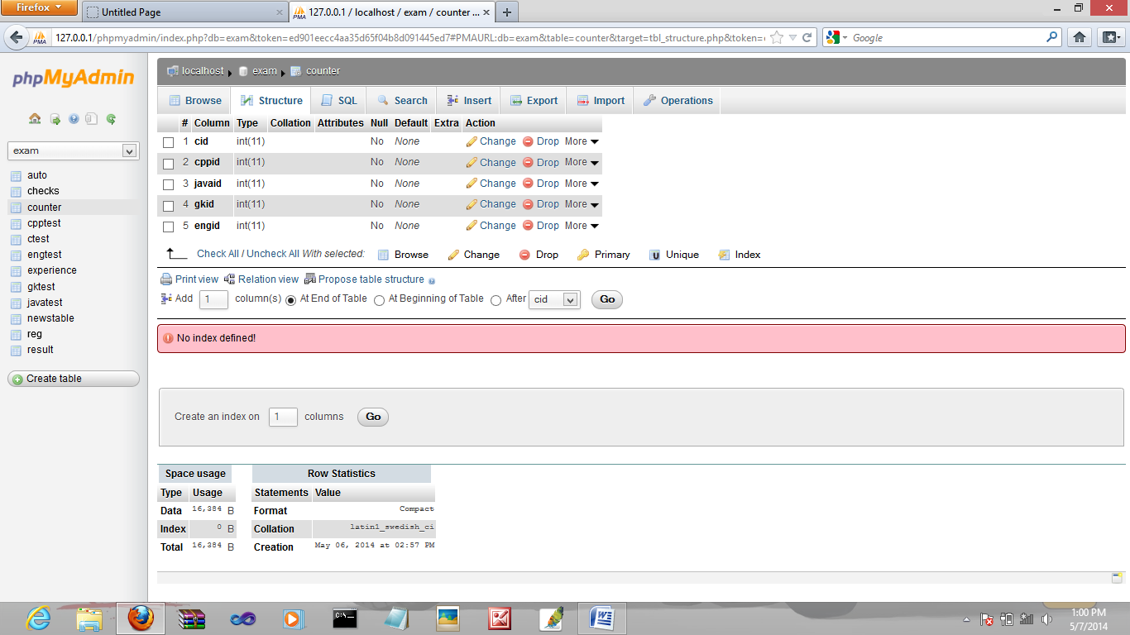

3.2 Reports Generated By the System
- List of Students who have given Skill Matrix
- Subject in which he has given Skill Matrix
- Number of correct answers in a given subject
- Number of incorrect answers in a given subject

